Developing the Young
Workforce at Crathie School
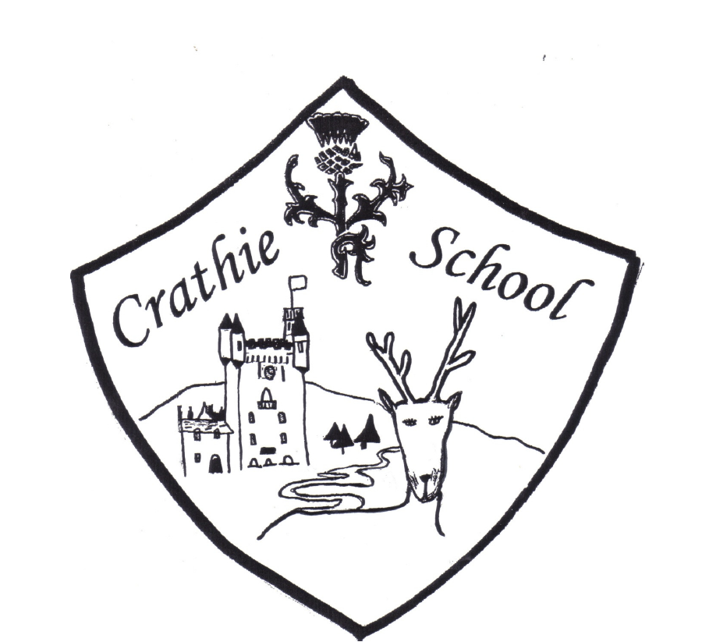

Revision | Details | Date

Developing the Young Workforce at Crathie School
‘Curriculum for Excellence is designed to transform education in Scotland, leading to better outcomes for all children and young people. It does this by providing them with the knowledge, skills and attributes they need to thrive in a modern society and economy laying the foundation for the development of skills throughout an individual’s life. Providing individuals with skills helps each individual to fulfil their social and intellectual potential and benefits the wider Scottish economy.’ (Building the Curriculum 4, 2009, p. 4)
At Crathie School we support all children and young people in developing skills which they will use throughout their life and work. These skills for life and skills for work are embedded across all curriculum areas through our Crathie Curriculum Framework and our Curriculum Rationale. Pupils develop enterprising, personal skills, cognitive skills and the opportunity to put learning in to a practical context. A strong focus on literacy and numeracy is essential. All children require these skills to gain access to learning and to succeed in life. Confidence and competence in literacy and numeracy provide the foundations for lifelong learning, and the health and wellbeing curriculum includes a range of opportunities to develop skills for life and work including working with others and early career planning.
At Crathie School we make links between the learning in the classroom and the workplace to help young people see the relevance of their learning and to understand the contribution they can make to the school, their community and eventually to the local economy. They can feel valued and involved and experience challenge and enjoyment, increase confidence and positive about their attainment and achievement.
Learners at Crathie School …
- experience a curriculum through which they learn about the world of work and job possibilities and which makes clear the strengths and skills needed to take advantage of these opportunities
- develop skills for learning, life and work as an integral part of their education and be clear about how all their achievements relate to these
- have opportunities to engage in profiling that supports learning and the development of skills for work and future career choices
- are part of a learning environment that recognises and promotes diversity and supports them to understand that it is everyone’s responsibility to challenge discrimination
- have the opportunity to build knowledge and understand of the work place by working with a range of partners including parents/carers and employers who contribute to curricular learning activities.
- are made aware of the relevance of their learning and how it links to adult life or life outside school.
- have regular opportunities to reflect on where people work in their own families.
- have the opportunity every year to experience enterprising activities and to develop enterprising skills such as team work, creativity and problem solving.
- are building capacities throughout the curriculum as a whole to become successful learners, confidence individuals, responsible citizens and effective contributors which will support them as they move onto positive destinations after school.
- experience a transition experience to enable them to continue to develop skills for learning, life and work as they move to the senior phase.
- have individual opportunities to engage with industry e.g science at Techfest or Technology thorugh K’nex Challenge to promote business and industry.
- are encouraged to develop skills and opportunities for personal achievement outside school. They reflect on how this learning builds their personal capacities and skills for life, learning and work.
- Have opportunities to explore options in learning and work and relate this to personal priorities and strengths

Appendix: ‘I can’ statements

By end of Early Level: the pre-school years and P1, or later for some.

• I can communicate with people about the different jobs they do in my community.
• I can discuss some of the rewards that a job brings.
• I believe I can do any job.
• I can role play different job roles.
• I can follow rules and routines and explain why they are important.
• I can talk about my learning, my strengths and my next steps.
• I can develop ideas and take part in projects to make things.

By end of First Level: to the end of P4, but earlier or later for some.

• I can describe different jobs in my community and some of the skills needed for these.
• I can learn about the world of work from visits, projects and my experiences.
• I can talk to employers about myself and about their workplace.
• I can recognise that there are different ways to get a job.
• I can talk about the types of jobs that interest me.
• I believe I can succeed in any area of work.
• I can talk about my strengths, interests and skills and show evidence of my progress.
• I can set goals and work towards achieving them.
• I can adopt different roles when running a business.

By end of Second Level: to the end of P7, but earlier or later for some.

• I can discuss the relevance of skills to the wider world and make connections between skills and the world of work.
• I can explain to others my ambitions/what I would like to do and look for ways to achieve them/that.
• I can recognise the skills I have and need for work.
• I can apply my skills to get more information about jobs/careers.
• I can use online tools available to me.
• I own and can manage my profile and can use it to help me discuss my interests, strengths and skills with my parents/carers and others.
• I can identify people in my network who help me broaden my horizons.
• I believe I can maximise my potential in any type of work.
• I can identify different types of enterprise opportunities and engage in them.

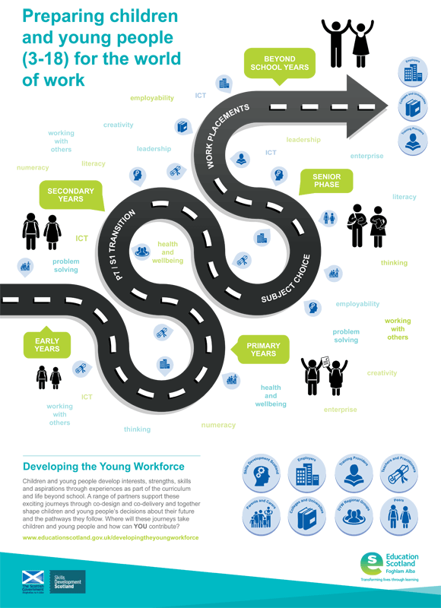

Building the Curriculum 4: skills for learning, skills for life and skills for work (Scottish Government 2009)
Developing the Young Workforce Career Education Standard (3-18) September 2015

