Crathie School Pupil Acceptable Use Agreement
At Crathie School we want to give our children as rich a variety of learning opportunities as possible. One of the ways of doing this is to give children access to technology to enhance their learning.

The internet provides a wealth of information which can enrich class work and enhance individual learning. It gives children the opportunity to develop digital literacy skills. Access to the internet will allow us to show off our pupils’ work by publishing it on their e-portfolio.

However, as you probably realise the internet has many sites which contain material which is unsuitable for children. Aberdeenshire Council works hard to filter unsuitable material and we try to ensure all internet access is supervised by a member of staff. These precautions are usually successful but obviously no system can be guaranteed.

We will explain to all pupils how to use the technologies available (i.e. school computers/ laptops, iPads etc) and the internet in an acceptable way before they are allowed access. These rules for acceptable use can be found on the following page. Any pupil who breaks these rules will not be allowed to use the technologies available or the internet in future and may face further sanctions for serious breaches of the rules.

It is important that there is a dialogue with children as to how they use technology at school and at home. There are many ways in which we can communicate with others online and children should be prepared to deal with any problems they may face. Pupils should be aware that their rights apply both on and off line.

Mobile phones are not permitted in school. No child should have their telephone with them at any point in the day. If there is any exceptional reason for a pupil requiring to bring a phone to school the school should be contacted and any special arrangements agreed. On these rare occasions it will be essential for pupils to give their phone to a suitable adult for safe keeping.

Please sign the form overleaf and return by Friday the 21st of December.

Thanks,

Mr Clark

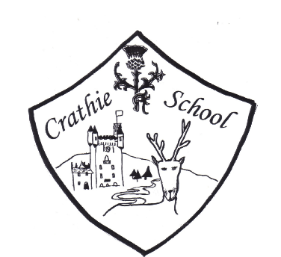

Crathie School Pupil Acceptable Use Agreement
Technology use and internet access should be supervised by a member of staff. When pupils are allowed to use technologies and the internet they are expected to follow the list of rules below.

This is how we stay safe when we use computers:
- I will ask a teacher or adult if I want to use the computers / tablets.
- I will only use technology that a teacher or suitable adult has told or allowed me to use.
- I will only use technology for educational activities.
- Only upload or download files with permission from a suitable adult.
- I will only access files meant for me.
- I will only take photos of people after getting their permission.
- I will take care of the computer and other equipment responsibly.
- I will ask for help from a teacher or suitable adult if I am not sure what to do or if I think I have done something wrong.
- I will tell a teacher or suitable adult if I see something that upsets me on the screen.
- I agree to follow these rules. I understand that they are intended for my own safety and others.

Child Signature: __________________________________________

Parent Signature: _________________________________________

Date:___________________________________________________

