**Crathie Primary School Digital Technologies Plan**

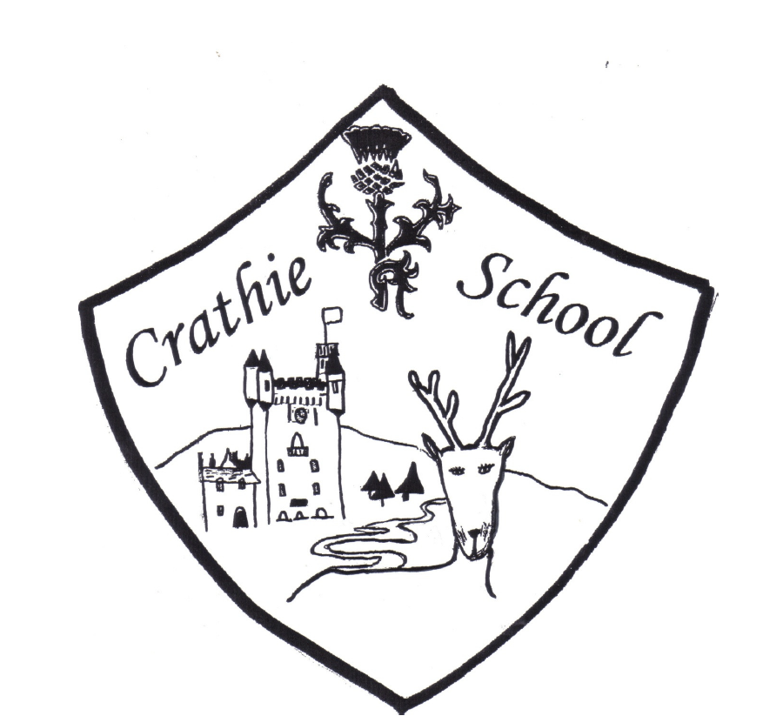

|  |  |  |
| --- | --- | --- |
| **Revision** | **Details** | **Date** |
| Changed from Class Dojo to SeeSaw in line with GDPR compliance. |  | 11/12/2018 |

**Introduction**

*“We must provide our learners with relevant and contemporary experiences that allow them to successfully engage with technology and prepare them for life after school.”*

*Education Scotland (2012)*

It is important that the pupils at Crathie Primary School are prepared for an increasingly digital world. The children are required to develop both digital literacy and digital citizenship skills, suitable for today and tomorrows technology laden culture.

Technology is at the heart of learning at Crathie School and the children have technology available to use as required. Technology is used extensively in teaching to build a range of skills, from word processing to coding, and it is also used to highlight the potential pitfalls of social media and internet use.

At Crathie we aim to:

* Use ICT to support learning needs for all learners.
* Develop digital literacy skills in a cross curricular way.
* Develop a knowledge and understanding of e-safety.
* Discover new technologies and consider their future impact.

**The Role of a Primary School in Enhancing Learning Through Technology Use**

Enhancing Learning Through The Use of Digital Technology: A Digital Learning and Teaching Strategy for Scotland.



**Leadership and Vision**

There are many references to digital learning within our School Development Plan. Indeed, the school has invested heavily in hardware through the Pupil Equity Fund. We have purchased ipads and Chromebooks to aid teaching and learning and we now have more than 1 device to 1 pupil. Our CPD budget supports digital CPD and opportunities have been given to teaching staff to broaden skills.

Crathie School has embraced the new structure for staff at local authority level and in the role of staff Digital Leader the Principal Teacher uses platforms such as Yammer to engage in local authority developments such as the Bennachie Campus which is a local collaborative and sharing area. Staff use Technologies Experiences and Outcomes to inform planning and the Digital Learning Community to look at best practice.

The school took part in National Digital Learning Week, looking at how technology impacts on jobs as well has hosting a coding event for parents.

Crathie School recognises the importance for e-safety learning at school. E-safety progresses through the school from developing an understanding of setting passwords to using social media. The children have also reflected upon and can discuss their digital footprint. We do, however, recognise that this is an area where we can improve through working with parents to raise their understanding of how important this issue is.

Technology is managed by the pupils, for the pupils. They take turns to store, challenge and even, at a basic level, troubleshoot issues in a collaborative manner. This duty is carried out daily and the pupil in charge is paid for this through classroom bucks which forms that Crathie School Economy. Beyond this, the school work with the local authorities ‘Ask Fred’ scheme to solve technical issues.

**Use of Digital Technology to Deliver the Curriculum**

The children enjoy using digital technology in all areas of the curriculum. The children read e-books, develop mental maths skills, research, take photographs, film and write using technology. Examples are displayed below. During presentations and sharing learning events, children can choose to use technology. There are a range of apps available for pupils to use, depending on ability. For instance, Early Years pupils have apps such as Jolly Phonics and Puppet Pals to aid literacy skills. For older children, flipped learning platforms such as Khan Academy are used to extend understanding. Children always have the opportunity to use technology to learn independently during free play.

**School Culture**

Crathie School is a digital learning environment where pupils enjoy using technology to enhance their learning. There is a digital culture embedded at school where children have access as required as well as receiving more structured tuition in improving digital literacy skills.

We use technology to communicate with parents and the wider community. We have been successful in using twitter (<https://twitter.com/Crathie_School)> to establish partnerships and promote our work. We also use SeeSaw to communicate with parents and as a Pupil Portfolio tool. We recognise that to improve further there is a requirement to improve the relevance of the school website (<http://crathie.aberdeenshire.sch.uk/)>.

As well as using Pupil E-Portfolios the school has a digital learning wall where we share evidence of class work.

**Professional Development**

The Principal Teacher is a former ICT Co-ordinatory at a previous school and has experience in establishing ICT infrastructure and in the Google eco-system. This will be built upon through future CPD. The Principal Teacher is a Digital Leader at local authority level and is also looking to receive Google Educator Accreditation. There are links with professionals involved with digital education and there blogs and journals are accessed as part of ongoing CPD to keep abreast of new technologies and local and national developments.

E-safety is at the heart of learning at Crathie School. The Acceptable Use Policy is signed on an annual basis and referred to and reflected upon regularly.

**Resources and Infrastructure**

The school is a 1 pupil to 1 device school. The children have access to ipads and Chromebooks and can freely access these devices as and when they wish. The school has a Dash and Dot robot that is used to develop programming skills. The children have also worked on coding by using Scratch and Scratch jr. We hosted a Coding Day in February of 2018 where we invited parents to take part in coding with Scratch so that the children could transfer skills. As mentioned above, the children use SeeSaw to add to e-portfolios and Primary 7 pupils use the My E-Portfolio tile on Glow as a link between primary and secondary school. The school use Sumdog to improve mental arithmetic and spelling skills. The Smart board is used as an interactive teaching tool on a regular basis.

The school is about to embark upon a local authority led ICT refresh program where old hardware will be taken away as they cannot support new software. Some finance will be made available in return for old hardware taken away. The investment in ipads and Chromebooks was made in preparation for this change.

**School Aims**

**Use ICT to support learning needs for all learners.**

Improving attainment in literacy and numeracy is one of our priorities identified in our Standards and Quality Report (SQUIP 2018). ICT plays a key role in this priority to support learning needs. One way we do this is through digital learning games to consolidate existing learning. For example, we have invested in Sumdog (<https://www.sumdog.com/)> , a learning game platform, to improve mental maths fluency and spelling. We were even local champions in a Sumdog competition. We also use ipads as a reading tool. We use Oxford Owl Online (<https://www.oxfordowl.co.uk/)> to access a range of e-books which the children regularly use as part of guided reading tuition. We use the internet as a research tool to improve note making skills. We are also using technology to create digital portfolios where pupils take photos of best work and describe its impact.

What we will do to improve:

* Continue to invest in Sumdog to develop mental arithmetic and spelling.
* Build on use of e-books through investment in Kindles from Parent Forum.
* Continue to build digital portfolios as a communication and assessment tool between home and school.

**Develop digital literacy skills in a cross curricular way.**

We believe that using technology to improve digital literacy will impact positively upon other curricular areas. We teach digital literacy skills to enhance other areas of learning – from creating presentations on the Cairngorms to programming a robot to follow compass directions. For example, we write a school newspaper and contribute to a local news publication, documenting what has been happening in school using word processing software. This is done in small groups with adult guidance.

What we will do to improve:

* Establish a bank of trusted web sites that are differentiated by level.
* Develop an awareness of searching, processing and managing information responsibly as identified in the Technologies Experiences and Outcomes. (<https://education.gov.scot/Documents/Technologies-es-os.pdf)>

**Develop a knowledge and understanding of e-safety.**

Ensuring that pupils are aware of the potential pitfalls of using technology is critical in modern Scotland. As a Gold Level Rights Respecting School we believe that children should be aware that their rights apply both on and offline. We also aim to ensure that children have strategies in place for dealing with challenges they may face online. All digital users are required to sign an Acceptable Use Policy to highlight the responsibilities that digital users have.

What we will do to improve:

* Use local police talk in connection to e-safety, inviting parents to be part of discussion.
* E-safety session for parents. Highlight websites such as Parentzone (<https://education.gov.scot/parentzone)> and Go Safe Scotland (<https://www.gosafescotland.com/)> that can be used to access e-safety guidance.
* Continue to review Acceptable Use Policy.

**Discover new technologies and consider their future impact.**

We are aware that technology is constantly evolving and that Crathie School should be equipped to deal with these changes. Our Principal Teacher is a Digital Leader at Local Authority level and uses this as a CPD tool for discovering new technologies and initiatives. We have finance available for investing in training. We have used PEF money from last year to invest in ipads and Chromebooks for pupils. As a result, we are now a 1 pupil to 1 device school.

What we will do to improve:

* Establish Google Calendar and Google Classroom for staff.
* Principal Teacher to achieve Google Educator Level 1 status.
* Investigate new technologies with pupils and their impact upon Developing the Young Workforce.
* Use the newly established, local authority created, Bennachie Campus (<https://blogs.glowscotland.org.uk/as/learninginaberdeenshire/)> as a CPD and collaboration tool.
* Further develop and add to the school website.

**Evidence of Digital Learning at Crathie School**

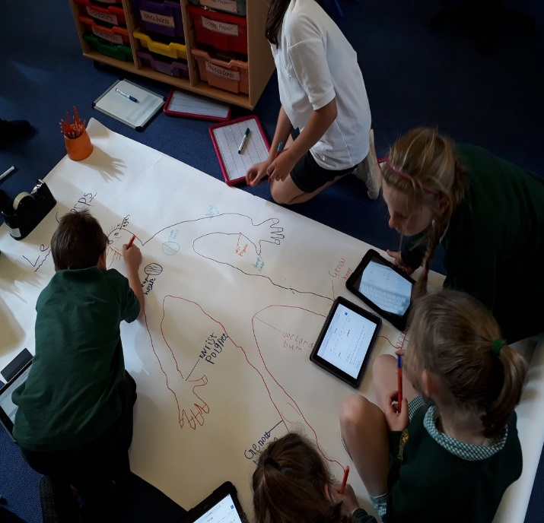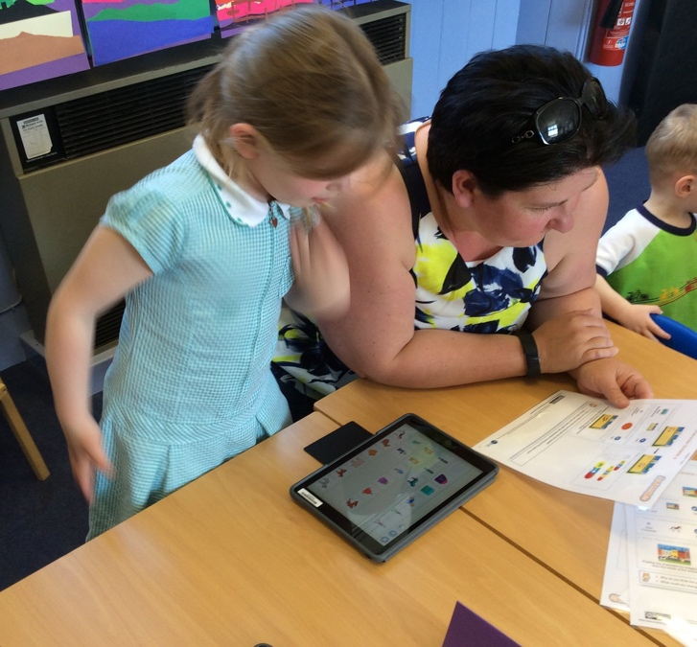

Coding with Parents

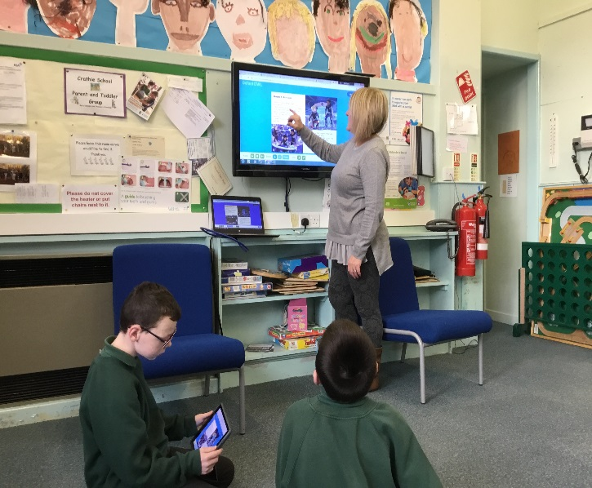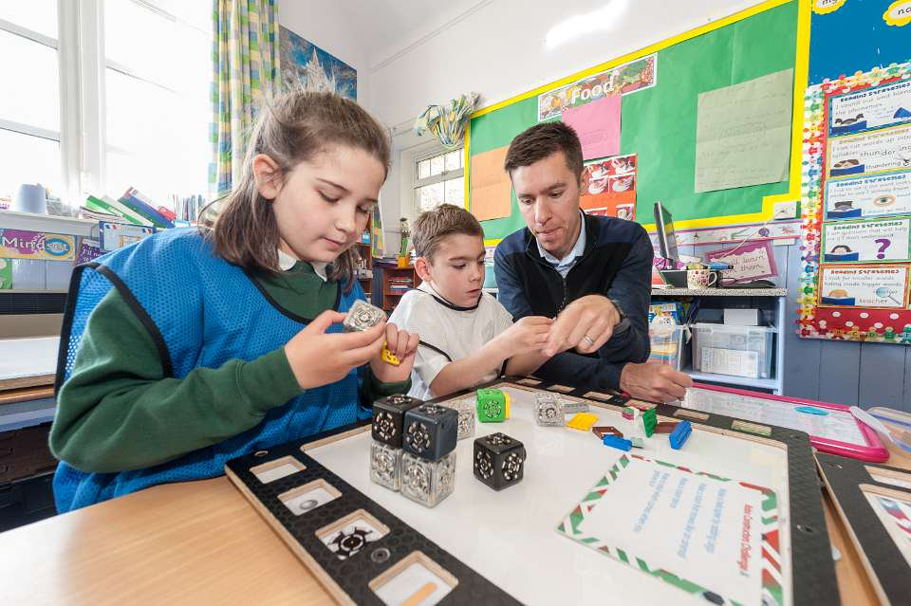

Reading E-Books

Translating French Body Parts

Programming Robots to Draw.

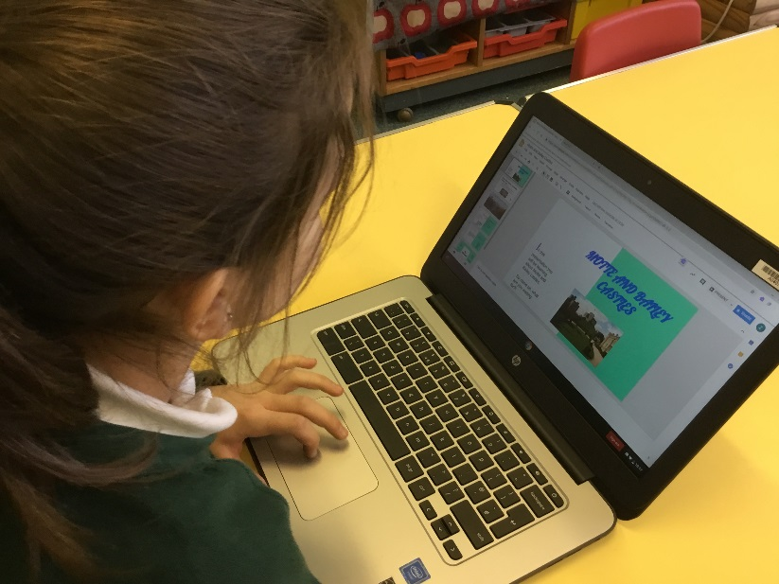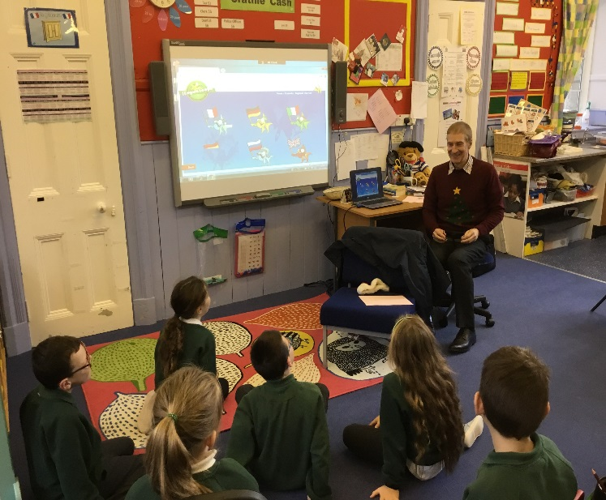

Creating and Presenting Research

Multi Language Learning

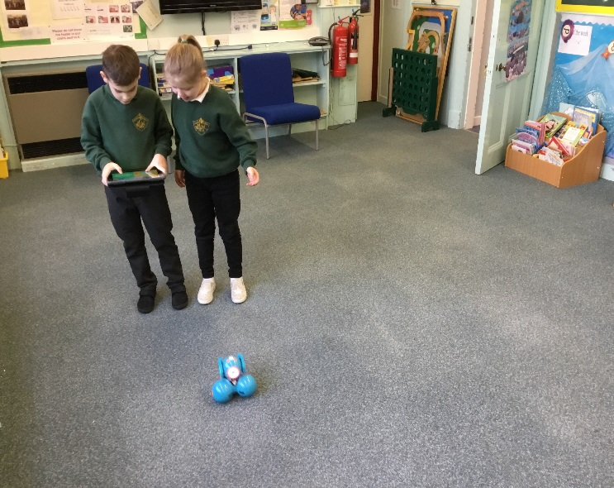

Programming Dash and Dot